Distribution of Police Stations in the Metropolitan cities of India

Introduction

Suppose a person has landed a job in one of the metropolitan cities of India. He wants to shift there and is looking for a safe locality to live. Or a parent’s child is shifting to one of these cities for pursuing his/her studies and they’re concerned about the safety of their child and want to find out how well connected the city’s police network is. Or a person already living in the city needs to know the location of the police station nearest to their home or workplace. For these purposes we will use Foursquare API to make queries and perform some analysis on the data provided to us.

Description of the Data

Being the Metropolitan Cities, there are a lot of educational opportunities, new job vacancies, etc. every year. So a lot of people are attracted to these cities.

We take into account 4 cities- New Delhi, Bangalore, Mumbai and Lucknow.

Therefore, we perform our analysis on these 4 cities.

Methodology

The main target here is to asses which city would have the highest density of Police Stations. I used the Four Square API through the venues channel. I used the explore query to get venues in the cities. Also, I used the CategoryID to set it to show only Police Stations. An Example of my requests is shown below.

<https://api.foursquare.com/v2/venues/explore?&client_id=&client_secret=&v=20180605&New> Delhi,National Capital Territory, India&limit=100&categoryId=4bf58dd8d48988d12e941735

4bf58dd8d48988d12e941735 is the Foursquare Id of Police Stations. Also, Foursquare limits us to maximum of 100 venues per query.

Moreover, I repeated this request for the remaining 3 cities and got their top 100 venues. I saved the name and coordinate data from the result and plotted them on the map for visual inspection.

Next, to get an indicator of the density of Police Stations, I calculated a center coordinate of the venues to get the mean longitude and latitude values. Then I calculated the mean of the Euclidean distance from each venue to the mean coordinates. That was my indicator-mean distance to the mean coordinate (MDMC).

Results

For our initial visual inspection we see that all the cities have varying number of police stations.. The following here are the pictures of the geoplot generated with folium:

NEW DELHI

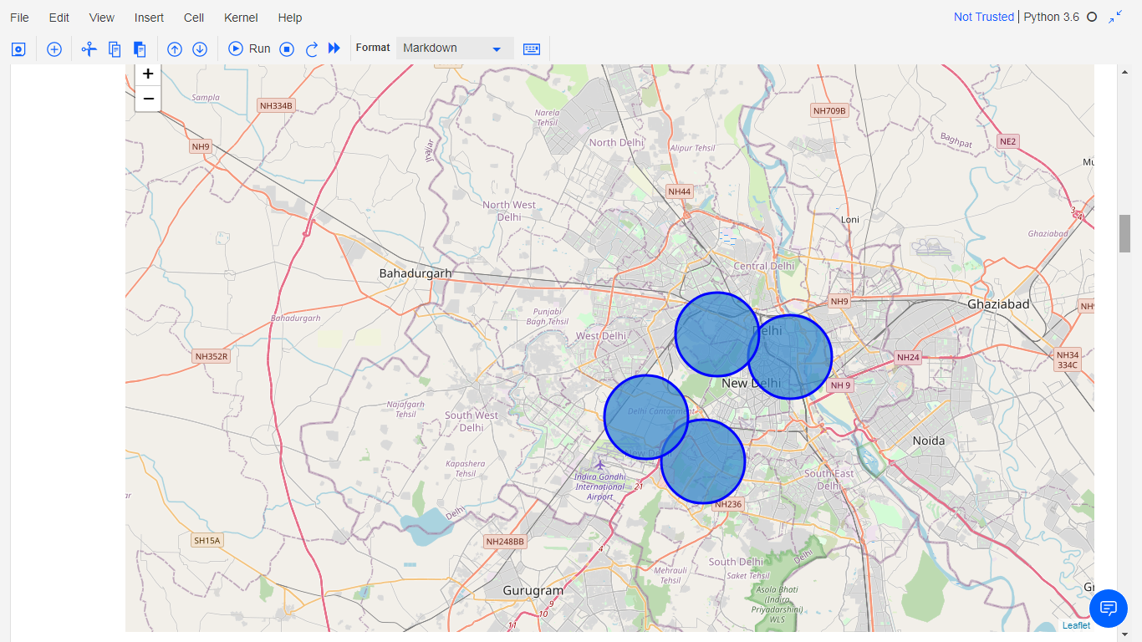

BANGALORE

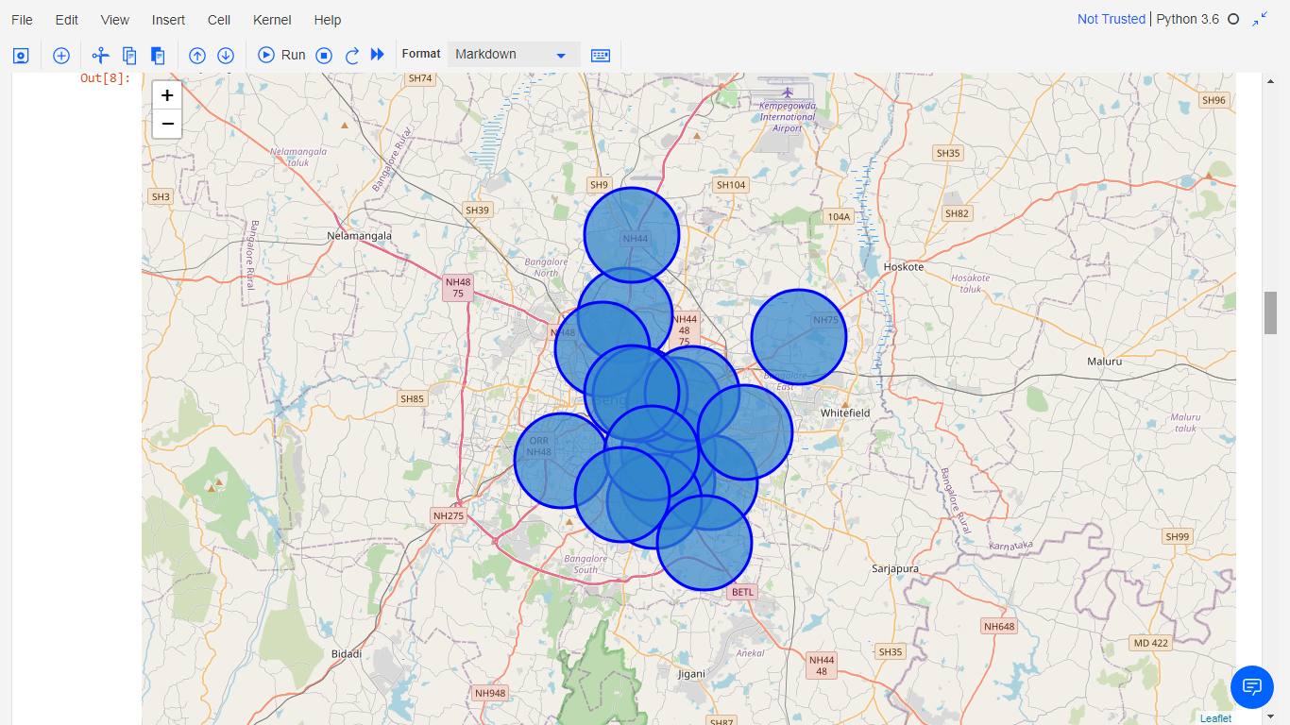

MUMBAI

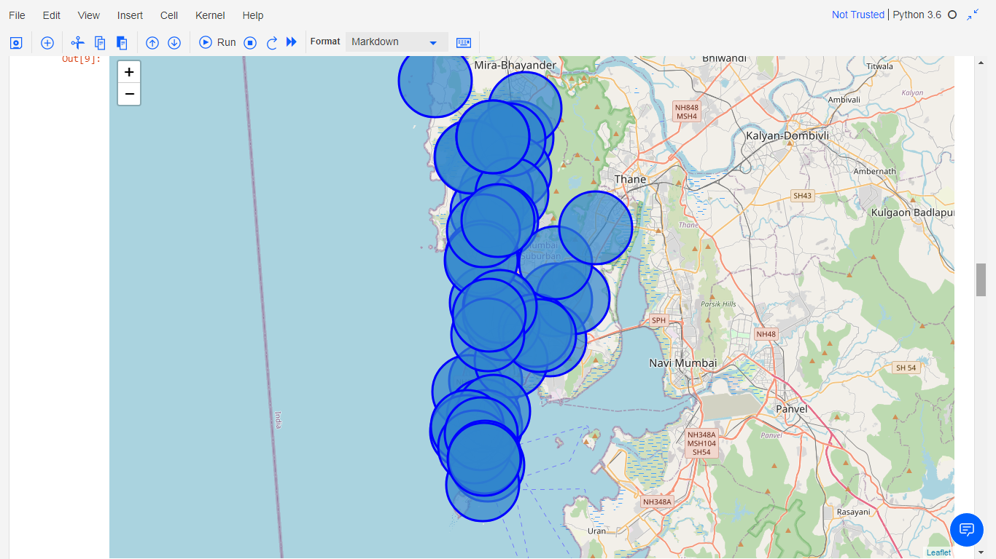

LUCKNOW

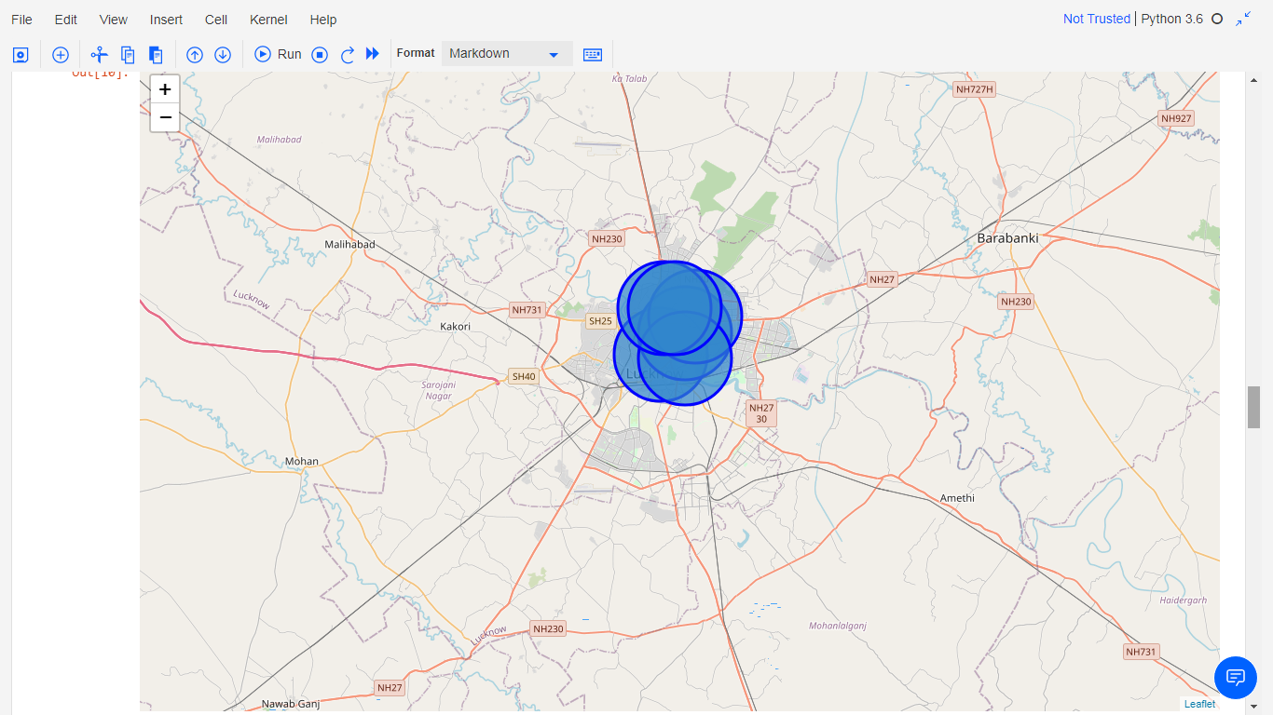

Upon First inspection we see that Bangalore and Mumbai are the most dense cities in terms of police station network.

Next we Calculate the Mean coordinate and the mean distance to mean coordinate (MDMC). We represent the mean coordinate with a big green circle and distances with green lines.

NEW DELHI

MDMC 0.05473523082961468

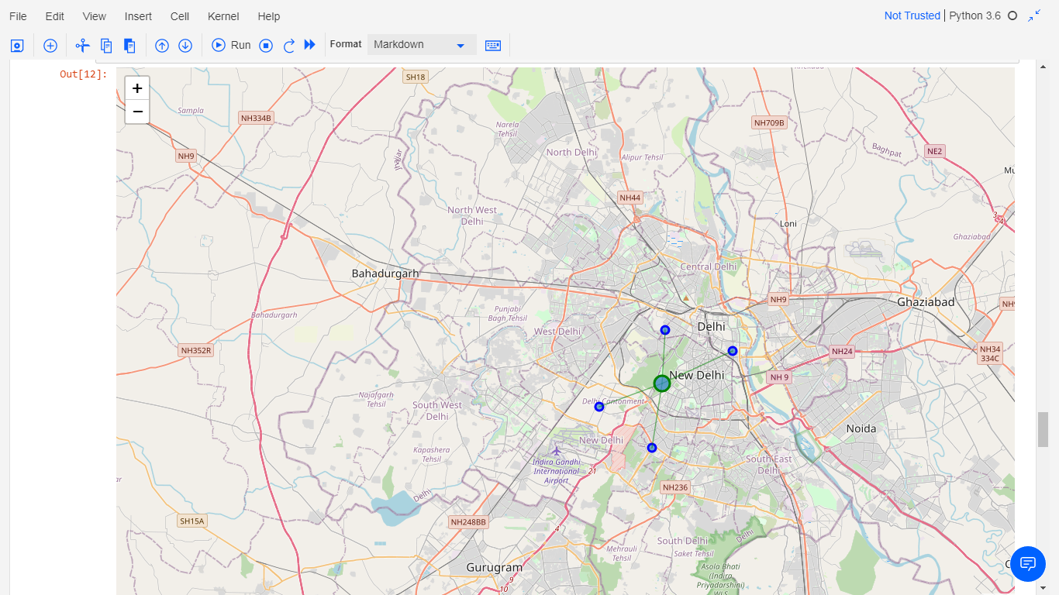

BANGALORE MDMC 0.05809142047400903

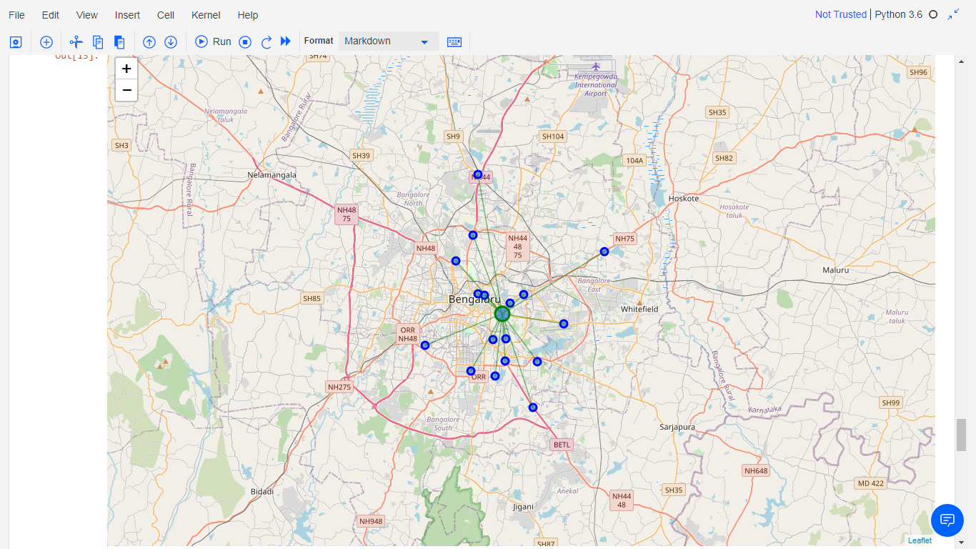

MUMBAI MDMC 0.09155085017257628

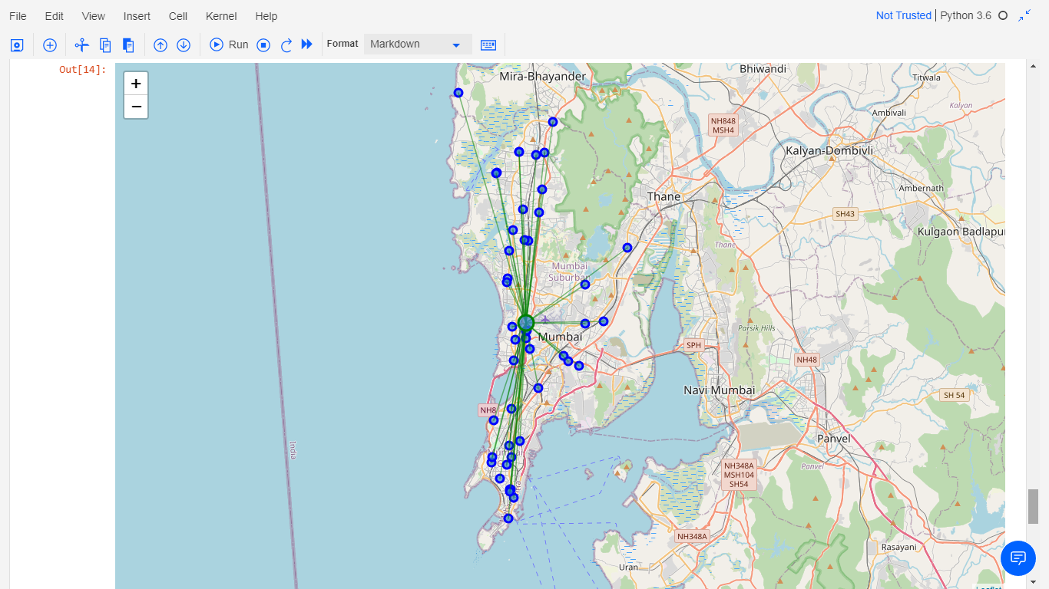

LUCKNOW MDMC 0.01558841116226777

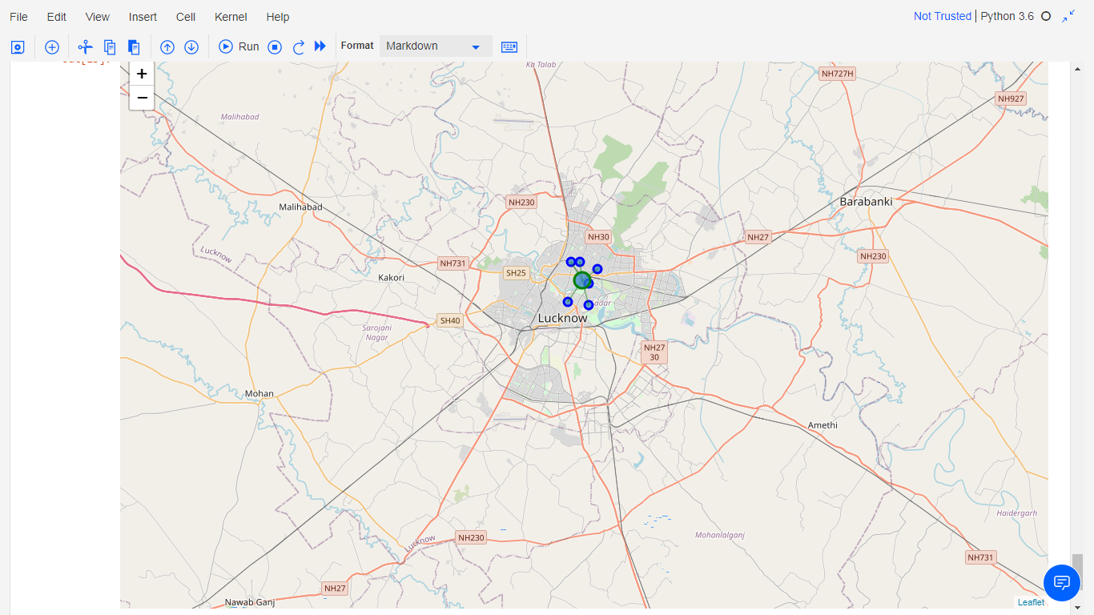

Discussion

Upon first inspection, we may conclude that Bangalore and Mumbai are well networked but after calculating the Mean Distance to Mean Coordinate (MDMC) we observe that even though thhe number of Police Stations in Mumbai is more, Bangalore is still more densely distributed with police stations.

Conclusion

We can hence conclude that in shifting to Bangalore a person can be relatively at ease and feel secure because of the well connected network of police stations there.